ASSIGNMENT TWO

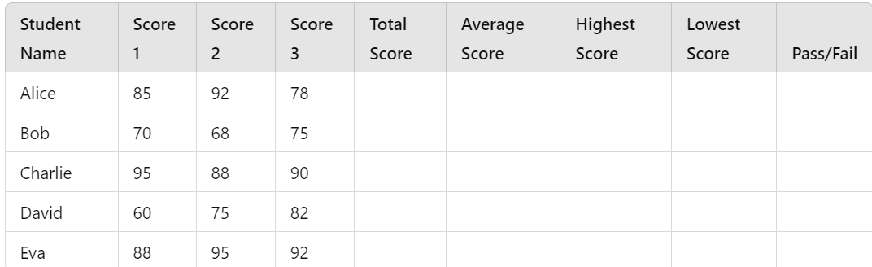

TO DO.

1. Compute the following;
2. Total Score for each student
3. Average Score
4. Highest Score
5. Lowest Score
6. Pass/Fail status for each student.(For a student to Pass, he /she must have an average score of 70% , below that it is a Fail Status)
7. How many students Passed?

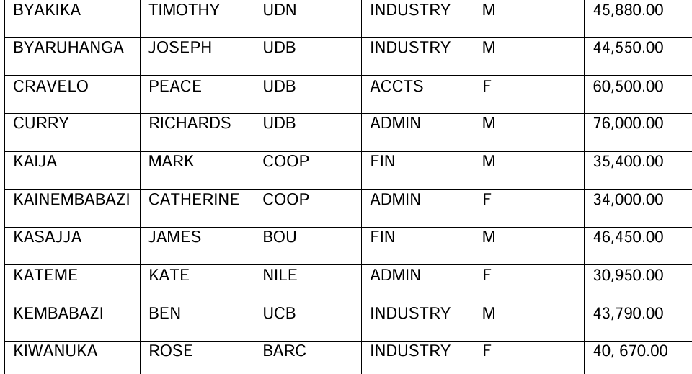

TO DO

1.Sort the last names so that they are in descending order.

2. Sort the records so that the departments are in ascending order

3. Filter the above list to reflect only the males

Create the following as three dimensional embedded charts using any of the fields from the table.

1. Line chart

2. Column chart

3. Pie chart